Information of NTOU's International Student Admission
國立臺灣海洋大學外籍學生招生資訊
- Eligibility申請資格
- Do not have Nationality of Republic of China and Do not meet the following conditions不具中華民國國籍且不具下列各情形者：
- Possesses overseas Chinese student status or has ever applied / studied in R.O.C. as an overseas Chinese student具有僑生身份，或曾以僑生身份在臺申請入學或就學者。
- Has applied and obtained a high school diploma as an international student in R.O.C. and would like to pursue a further degree曾以外國學生身分申請並取得高中學位，並希望繼續在臺申請就讀大學者。
- Has been expelled by a university or college in R.O.C.曾被國內大專校院退學者。
- Holds nationality of Hong Kong or Macau or People's Republic of China.具有香港或澳門或中華人民共和國國籍者。"
- Applicants for the bachelor's program must hold a high school diploma. Applicants for the master's program must hold a bachelor's degree. Applicants for the doctoral program must hold a master's degree.
申請學士班者，需具有高中學歷/申請碩士班者，需具有大學學歷/申請博士班者，需具有碩士學歷。
- Having Language Proficiency Certificate with Chinese B2 or English B1 (either one)語言能力檢定證明需達中文A2級或英文B1級

- Available Departments and Programs本校學系
- College of Maritime Science and Management海運學院
- Department of Merchant Marine 商船學系
- Department of Shipping and Transportation Management 航運管理學系
- Department of Transportation Science運輸科學系
- Department of Marine Engineering 輪機工程學系
- Bachelor Degree Program of Ocean Business Management海洋經營管理學士學位學程
- College of Life Sciences生命科學院
- Department of Food Science 食品科學系
- Department of Aquaculture 水產養殖學系
- Department of Bioscience and Biotechnology 生命科學暨生物科技學系
- Institute of Marine Biology 海洋生物研究所
- Institute of Food Safety and Risk Management食品安全與風險管理研究所
- Marine Biotechnology and Environmental Ecology Sustainability international master's degree program海洋生物科技及環境生態永續國際碩士學位學程
- College of Ocean Science and Resource海洋科學與資源學院
- Department of Environmental Biology and Fisheries Science環境生物與漁業科學學系
- Department of Marine Environmental Informatics海洋環境資訊系
- Institute of Earth Sciences地球科學研究所
- Institute of Marine Affairs and Resource Management海洋事務與資源管理研究所
- Institute of Marine Environment and Ecology海洋環境與生態研究所
- Doctoral Degree Program of Ocean Resource and Environmental Changes海洋資源與環境變遷博士學位學程
- College of Engineering工學院
- Department of Mechanical and Mechatronic Engineering機械與機電工程學系
- Department of Systems Engineering and Naval Architecture系統工程暨造船學系
- Department of Harbor and River Engineering河海工程學系

- College of Electrical Engineering and Computer Science電機資訊學院
- Department of Electrical Engineering電機工程學系
- Department of Computer Science and Engineering資訊工程學系
- Department of Communications, Navigation and Control Engineering通訊與導航工程學系
- Department of Optoelectronics and Materials Technology光電與材料科技學系
- College of Humanities and Social Science人文社會科學院
- Institute of Applied Economics應用經濟研究所
- Institute of Education教育研究所
- Institute of Oceanic Culture海洋文化研究所
- Institute of Applied English應用英語研究所
- College of Ocean Law and Policy海洋法律與政策學院
- Bachelor Degree Program of Ocean Law and Policy海洋法政學士學位學程
- Institute of the Law of the Sea海洋法律研究所
- Master degree Program of Ocean Policy海洋政策碩士學位學程

- Reauired Documents所需繳交文件
- A e-copy of passport / ID護照影本
- A e-copy 2-inch frontal photos2吋大頭照
- Affidavit with signature切結書(需親簽)
- A research / study plan研究計畫
- An authenticated photocopy of degree certificate最高學歷畢業證書(需經我國駐外機構驗證)
- An authenticated official transcript成績單(需經我國駐外機構驗證)
- A financial statement (with an amount of at least 150,000 NTD should be available in the account or a certificate of Taiwan government's scholarship)財力證明(金額須達美金5,000元或新臺幣150,000元以上，或政府、本校或民間機構提供全額獎助學金之證明)
- NTOU scholarship application form獎學金申請書
- Chinese or English language proficiency test transcript (Either Chinese A2 or English B1)語言能力檢定證明(需達中文A2級或英文B1級)

- Application Process申請流程
- Check the instruction and prepare all required documents確認申請資格及準備必要文件
- Access the application system, fill in personal information, and upload required documents進入海洋大學外國學生入學申請系統填寫資料並上傳必要文件
- Submission completed and await the application evaluation process完成申請件遞交"
- Get admitted and receive the letter of acceptance收到審查結果通知

- Application Duration申請期間
- Spring Semester: July 1 - October 30春季班:每年7月1日至10月30日
- Fall Semester: January 1 - April 15 秋季班:每年1月1日至4月15日

- Scholarship Condition獎學金條件
- NTOU Scholartship for International Student海大外籍生獎學金:
- Full tuition waiver學雜費全免
- Monthly allowance of USD 260-400 (the scholarship amount is not fixed and is subject to the decision of the scholarship committee every year).生活助學金臺幣8000元-12000元
- South East Asia Elite Scholarship Program新南向培英獎學金:
Monthly stipend of NT$25,000.每個月臺幣25000元補助
- Additional InformastionStudents can contact professors from the Key Labs directly to discuss the details of scholarships and future study and research.
You can find the list of our Key Lab scholarships and contact information at the following link部分實驗室亦提供額外獎助學金，可以參考此網頁: https://oia.ntou.edu.tw/p/412-1022-10366.php?Lang=zh-tw
- Contact Information聯絡資訊
Mr. Sean Cheng-Hsien Chang張正賢先生
(Division of International Cooperation 海洋大學國際事務處)：
Email： jo11382001@email.ntou.edu.tw oia@email.ntou.edu.tw

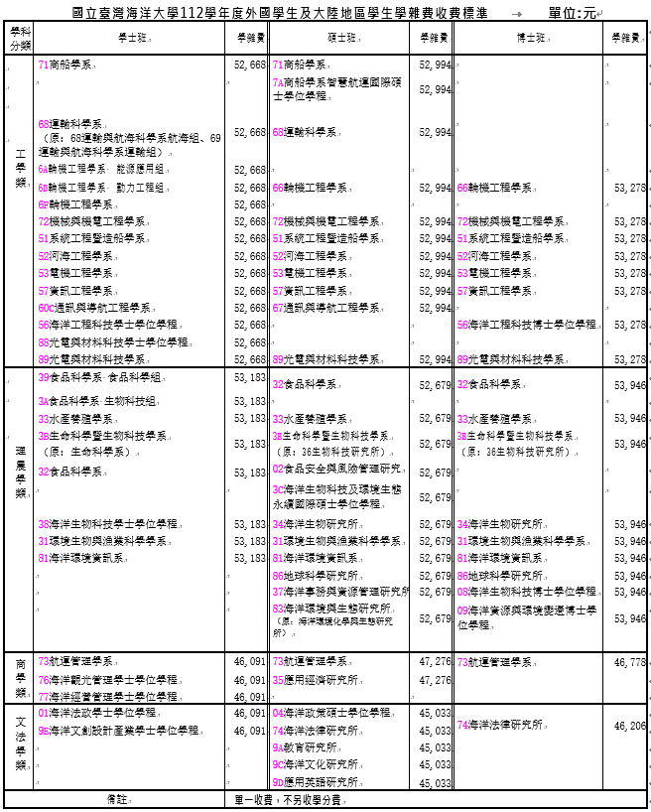

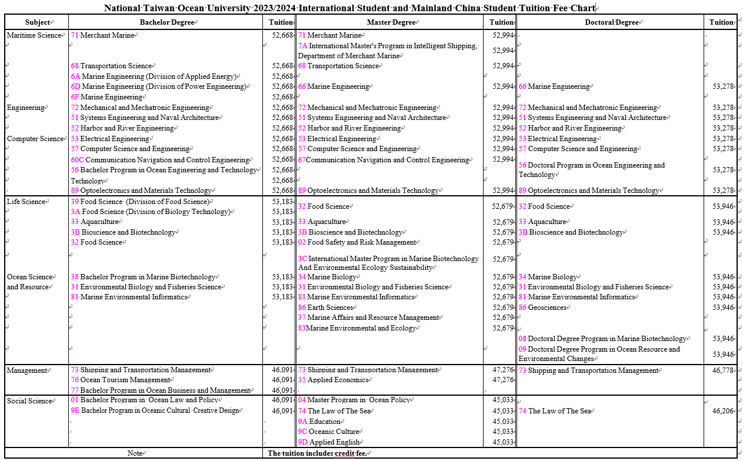

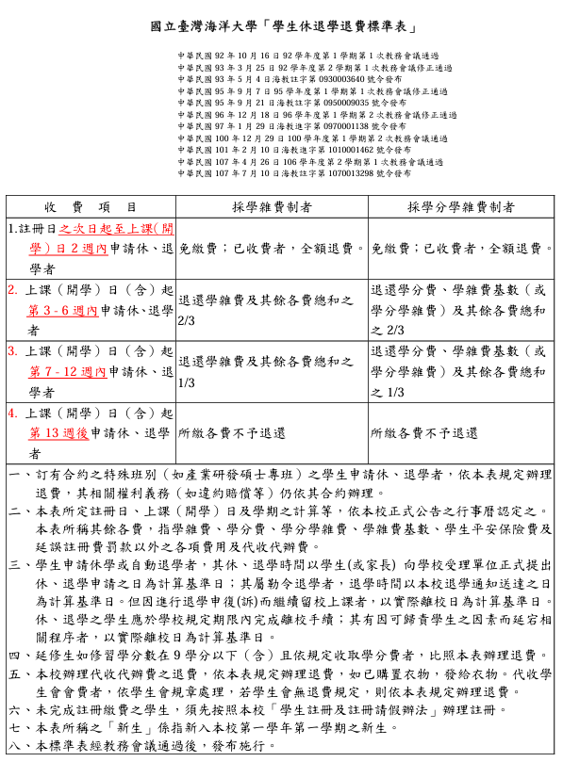

National Taiwan Ocean University
“Standard Table for Refunding for Student Leaves of Absence and Withdrawals”

Approved by the first Academic Affairs Meeting of the first semester of the 2003 academic year on October 16, 2003.
Amended and approved by the first Academic Affairs Meeting of the second semester of the 2003 academic year on March 25, 2004.
Promulgated on May 4, 2004, through Hai-Jiao-Zhu-Zi No.0930003640.
Amended and approved by the first Academic Affairs Meeting of the first semester of the 2006 academic year on September 7, 2006.
Promulgated on September 21, 2006, through Hai-Jiao-Zhu-Zi No.0950009035.
Amended and approved by the second Academic Affairs Meeting of the first semester of the 2007 academic year on December 18, 2007.
Promulgated on January 29, 2008, through Hai-Jiao-Jin-Zi No.0970001138.
Amended and approved by the second Academic Affairs Meeting of the first semester of the 2011 academic year on December 29, 2011.
Promulgated on February 10, 2012, through Hai-Jiao-Jin-Zi No.1010001462.
Amended and approved by the first Academic Affairs Meeting of the second semester of the 2017 academic year on April 26, 2018.
Promulgated on June 10, 2018, through Hai-Jiao-Zhu-Zi No.1070013298.

Items | For those paying tuition and miscellaneous fees | For those paying tuition and miscellaneous fees per credit
1. Applications for leave of absence or withdrawal from the day following the registration day up to 2 weeks after the start of classes (including the day classes begin). | Exempt from fees; if already paid, a full refund will be issued. | Exempt from fees; if already paid, a full refund will be issued.
2. Applications for leave of absence or withdrawal from the 3rd to the 6th week after the start of classes (including the day classes begin). | 2/3 refund of the total sum of tuition, miscellaneous fees, and other fees. | 2/3 refund of credit fees, tuition fee base (or tuition per credit), and other fees.
3. Applications for leave of absence or withdrawal from the 7th to the 12th week after the start of classes (including the day classes begin). | 1/3 refund of the total sum of tuition, miscellaneous fees, and other fees. | 1/3 refund of credit fees, tuition fee base (or tuition per credit), and other fees.
4. Applications for leave of absence or withdrawal after the 13th week of classes (including the day classes begin). | No refund of any paid fees. | No refund of any paid fees.
1. For students in special classes with contracts (e.g., Industry Research Masters Programs), refunds for leaves of absence or withdrawals will be processed according to this table, and relevant rights and obligations (such as breach of contract compensation) will be handled according to their contracts.
2. The dates of registration, start of classes, and calculation of semesters will be based on the official academic calendar of the University. "Other fees" mentioned in this table refer to costs other than tuition, credit fees, tuition per credit, tuition fee base, student insurance fees, and late registration penalties.
3. For students applying for a leave of absence or automatic withdrawal, the date of application submission to the University's processing unit by the student (or parent) will be the basis for calculation. For students ordered to withdraw, the date of delivery of the withdrawal notice from the University will be used. However, if the withdrawal is appealed and the student continues to attend classes, the actual departure date will be used. Students on leave or withdrawing should complete the departure procedures within the University’s specified period; delays due to student-related factors will result in the actual departure date being used.
4. Students with delayed graduation taking 9 credits or less (inclusive) and charged per credit will have refunds processed according to this table.
5. Refunds of fees collected on behalf of the University will be processed according to this table; if clothing has been purchased, the clothing will be issued. For student council fees collected, the student council's regulations will apply. If no refund regulations exist, refunds will be processed according to this table.
6. Students who have not completed registration and payment must first register according to the University's " Regulations for Student Registration and Leave of Absence."
7. The term "new students" refers to students newly admitted in the first semester of their first academic year at the University.
8. This standard table will be implemented upon approval by the Academic Affairs Meeting.

Note: These regulations are formulated in Chinese. In case of any discrepancies between the English and Chinese versions, the Chinese version shall prevail.

